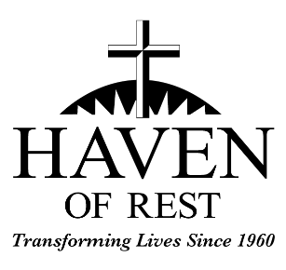
Part Time Employee Benefits

90 Days – Part Time Employees will be offered the following benefits after 90 days of satisfactory employment:

- Life Insurance: A Life Insurance benefit of $10,000 and Accidental Death and Dismemberment benefit of $10,000. There is no cost to the employee as The Ministry pays 100% of the cost. Your coverage becomes effective on the 1st of the month following your 90-day initial period.
- Voluntary Life Insurance: A supplemental Life Insurance benefit and Accidental Death and Dismemberment benefit. (employee pays 100% of the cost). This benefit is available to employees through voluntary payroll deductions.

- Employee Savings: Our employees are eligible for membership with the Anderson Federal Credit Union.

- Cafeteria Plan: This plan is designed to provide a tax break for both the ministry and our employees. It allows your premiums paid for certain benefits to be exempt from Federal and State Income taxes.

- Paid Time Off (PTO): Paid vacations are outlined in your employee handbook.

- Teladoc: allows for employee to talk to a doctor anytime, anywhere, by phone or video consult at no charge (employer pays 100% of the cost).

- Dental Insurance Plans: are also available to employees through voluntary payroll deductions (employee pays 100% of the cost).

- Vision Insurance Plans: are also available to employees through voluntary payroll deductions (employee pays 100% of the cost).

- Accident Insurance Plans: are also available to employees through voluntary payroll deductions (employee pays 100% of the cost).

- Critical Illness Insurance Plans: are also available to employees through voluntary payroll deductions (employee pays 100% of the cost).

1 Year – Part Time Employees will be offered the following benefits after 1 year of satisfactory employment if they work 1,000 hours within the prior year:
- 401K Savings Plan: The Ministry will match your contribution “dollar for dollar” up to 6% of your yearly income.

